Tanner Vazquez

Name of Project: (Final Project) Project.java

Project Description: Make a code that reads from a given data file (.csv) which reads from a set of company names, addresses, phone numbers, etc. The goal is to prints 2 text files out after reading from the given .csv file and sort the data into 2 data files. One text file is Good Data that has all 8 data elements. The other text file is Bad Data that does not contain all 8 elements. For this Bad Data file, the Row Numbers will show instead of the full lines of Data.

Date: 10/18/2020

Screenshots:

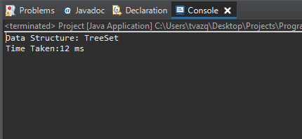

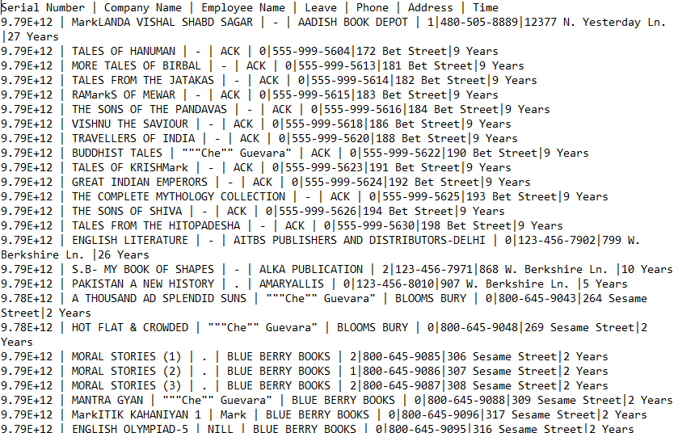

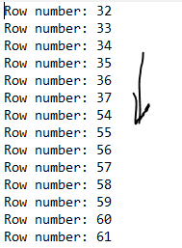

Source code will be attached as a .java file. Do not want to clutter.

No errors to end with. 😊 Thank you, sir.